GCP Overview:

General

* Introduction to Cloud Computing
* GCP Overview
* Exam Overview
* Setting up the GCP Environment and billing
* Pricing calculator and budget

Compute Services

* Compute Options
* Compute Engine
* Container Engine/Kubernates
* Kubernates node management demo
* App Engine
* Cloud Functions
* Cloud Run
* Exam Review

Database and Storage

* Storage Options
* Cloud SQL
* Cloud Spanner
* Big Table
* Cloud Datastore
* Transferring Services
* Cloud Storage Core Usage
* Cloud Storage Advance Usage
* Exam Review

Networking

* Overview
* VPC and Subnets
* VPN & VPC
* IP Addresses
* Cloud Load Balancing
* Cloud DNS
* Exam Review

Big Data

* Big Query
* Data Flow & Dataproc

Operations and Security

* Overview
* Stackdriver
* Cloud Deployment Manager
* Cloud IAM
* Marketplace
* Managing resources

GCP Essentials:

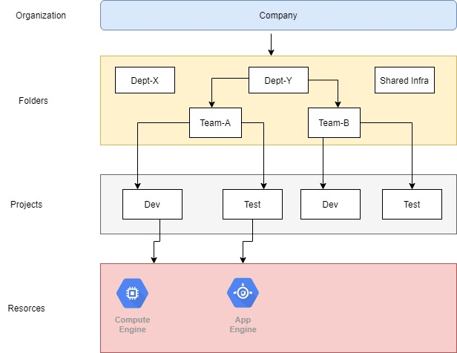

gcloud config set project <projectid>

gcloud projects list

gcloud projects describe <projectid>

**Compute Services:**

Compute Options:

Suite of products like VMs, containers and app platforms.

Fully managed, high performance, sereverless architecture.

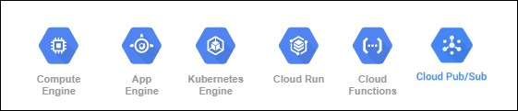

**Compute Engine:**

* Provides scalable Virtual Machines of all sizes – micro to 160 CPUs and 3.75 TB Memory.
* Local SSDs of 3TB and network storage of 64 TB in size – encrypted.
* Global load balancing to help distribute traffic across pools of instances.
* The infrastructure is maintained seamlessly via “live migration”

**Kubernetes Engine:**

* Fully managed container orchestration tool using the open source Kubernetes.
* Fully managed node experience - node auto repair, auto upgrade, node pools
* Autoscale on a high availability global network.
* Use VPC to create secure, isolated container networks.

**Cloud Pub/Sub:**

* Enterprise message system that can handle millions of messages per second.
* Uses a configurable publisher/subscriber mode for handling events and works with App Engine/Cloud functions/Storage and Compute.
* Used for ingesting events from sensors, data streaming, implementing asynchronous workflows and logging to multiple systems.

**App Engine:**

* Fully managed serverless application platform.
* Supports popular languages like Java, PHP, Node.js, Python, C#, .Net, Ruby and Go.
* Auto scaling of applications, infrastructure and network optimization.
* Used by Ed-tech companies like Khan Academy and mobile gaming companies like Rovio.

**Cloud Functions:**

* Easiest way to run your code in the cloud with no servers to provision.
* Extends to most products/services in the Google Cloud Platform
* Real time data processing and ability to integrate with third party services.
* Used for virtual assistants, chatbots, video/image/sentiment analysis.

**Cloud Run:**

* Serverless execution of containerized apps over HTTP
* Concurrent HTTP or Pub/Sub requests to running containers
* Run in Kubernetes or standalone
* Stateless workloads over abstract infrastructure